Lucent Technologies
Shreveport
Computype, Inc.
Nexstep Automation
1995 County Road B2, Suite J
St. Paul, MN 55113-2726
3-Axis Label Applicator
Operators Manual



Table of Constants
Introduction
Labeler Operation
Main form
File menu
Open Job form
IAI codes
IAI Runtime Codes
IAI Error Codes
Table of figures
Figure 1 Labeler Icon
Figure 2 Main form
Figure 3 File menu
Figure 4 Open Job Form

Introduction
This manual explains the general operation of the Labeler program. The labeler program is the software that allows the NexStep 3-Axis Labeler Applicator to print and place labels unattended. It is assumed that the reader is familiar with Microsoft Windows 95 terminology.

Labeler Operation

Figure 1 Labeler Icon
The labeler program is started by opening the Labeler Icon [Figure 1] on the desk top or under the start menu.
Labeler displays a splash while the subsystems are initialized. When the Labeler is complete initialized the Main form [See Figure 2 on page 2] is displayed.
Upon Labeler first startup an initial job must be chosen. This is done by clicking the New job button, by selecting File|Open job... menu option, or by typing the F2 function key.
Once the initial job is chosen then three options are available:
- A new job can be selected as described above.
- The job run can be started by clicking Press to Run button, by selecting the Run menu item, or by typing the letter R on the key board.
- The program can be exited by clicking the Exit button, by selecting File|Exit menu option.
Once the job is running Labeler needs to be stopped to select a new job. The job run can be stopped by clicking Press to Stop button, by selecting the Stop menu item, or by typing the letter S on the key board.
Labeler can be exited at any time as described above.

Main form
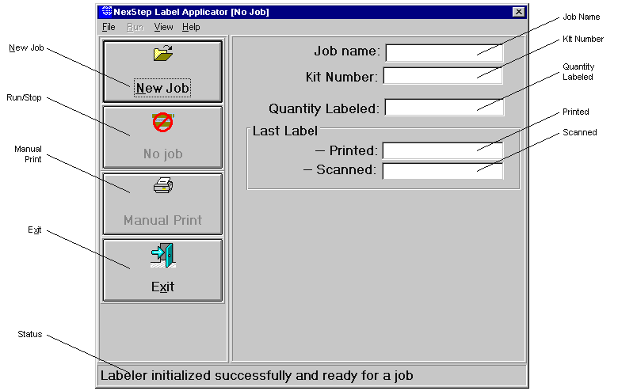
Figure 2 Main form
File menu
The file menu provides options for selecting a new job, new job database, printing a test label, resetting several of the sub systems, and exiting Labeler. See File menu on page 4
New Job
The new job button displays the Open Job form page 4.
Stop/Run
The stop run button is used to start or stop a job run.
Exit
The exit button is used to exit Labeler.
Status Line
The status line displays status messages about Labeler.
View menu
The view menu provides options several forms displaying technical information about Labeler and its subsystems.
Help menu
The help menu provides options to display the help file and the about form. The about form contains version information about Labeler and its subsystems.
Job Name
This window displays the job currently selected.
Concede
This window displays the condcode of the current job.
Quantity
This window displays the quantity of boards that have been labeled if it is a continuos job or the quantity of boards left to be labeled if a specified quantity job. See Open Job form on page 5.
Last label Printed
This window displays the last printed.
Last label Scanned
This window displays the last label scanned.
Note: Typically the last label printed and the last label scanned will be off by the print queue length (in the range of 6 to 7 labels).

File menu
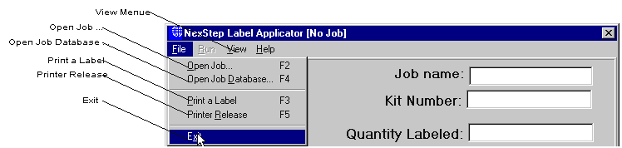
Figure 3 File menu
Open job
This menu item performs the same New job button and displays the File menu page 4.
Open job database
This menu item displays an open file common dialog box allow the selection of another job database.
Note: The database chosen must have the correct structure of a job database.
Reset
This menu item has several options to reset Labeler’s subsystems.
Exit
This menu item perfroms the same function as the exit button is used to exit Labeler.

Open Job form
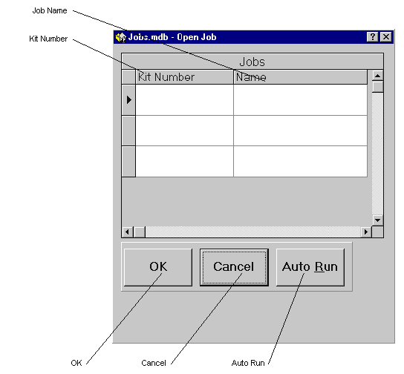
Figure 4 Open Job Form
List of jobs
This grid list the jobs that can be selected to run. Highlighting a row or any cell in the row and clicking on OK will select a job and return to the main form.
Quantity
The quantity window is where the number of panels are entered.
The quantity field functions in two ways. If the quantity filled in on this form is zero, a continuos job is assumed, then the quantity counts up. If the quantity filled in on this form is grater then zero then it counts down and when zero is reached labeling is stopped.
OK
Clicking the OK button close this form and sends the data chosen to the main form to initialize the job.
Cancel
Clicking the Cancel button closes this form and ignores any selections made.

